Noise analysis of electronic circuits

# Circuit Diagram



# Case A: Noise Analysis

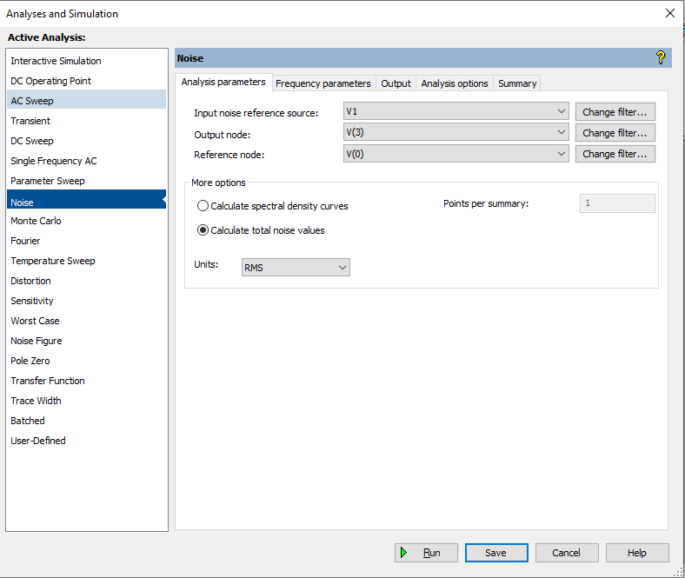

Necessary settings:

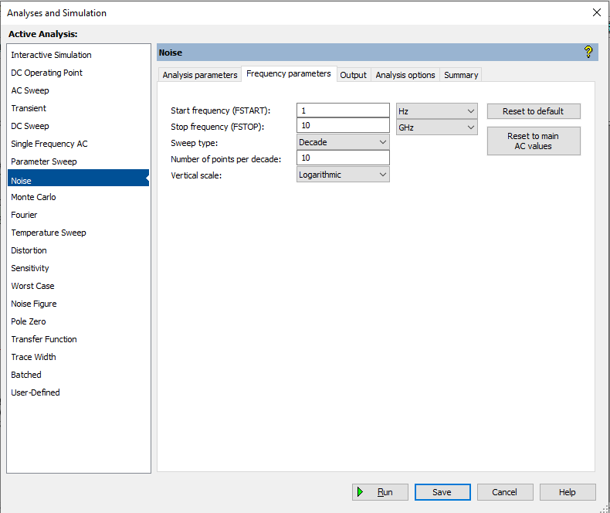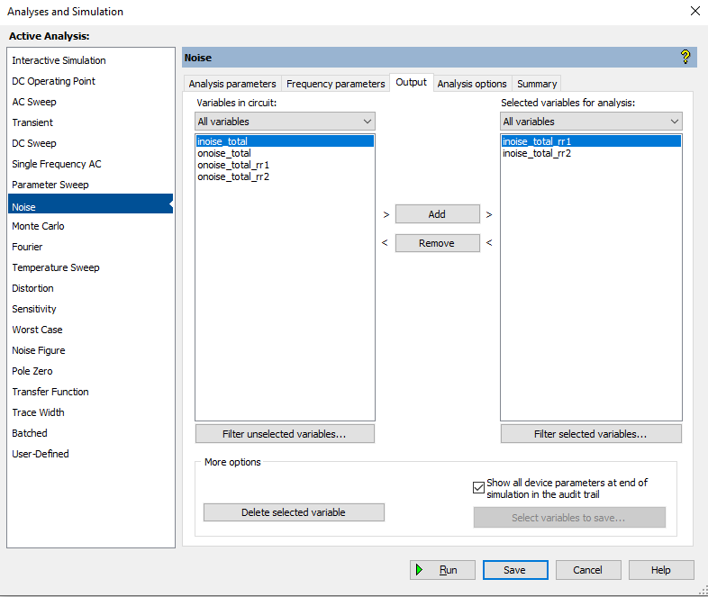

**Result of noise analysis:**

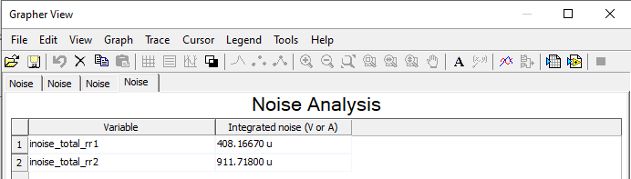

# Case B: Spectral density plot

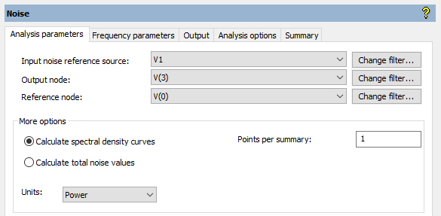Necessary settings (only the ones changed from the previous one):

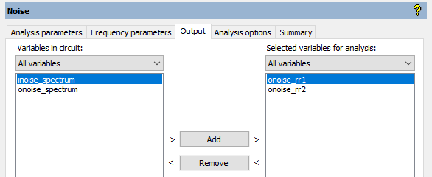

Results:

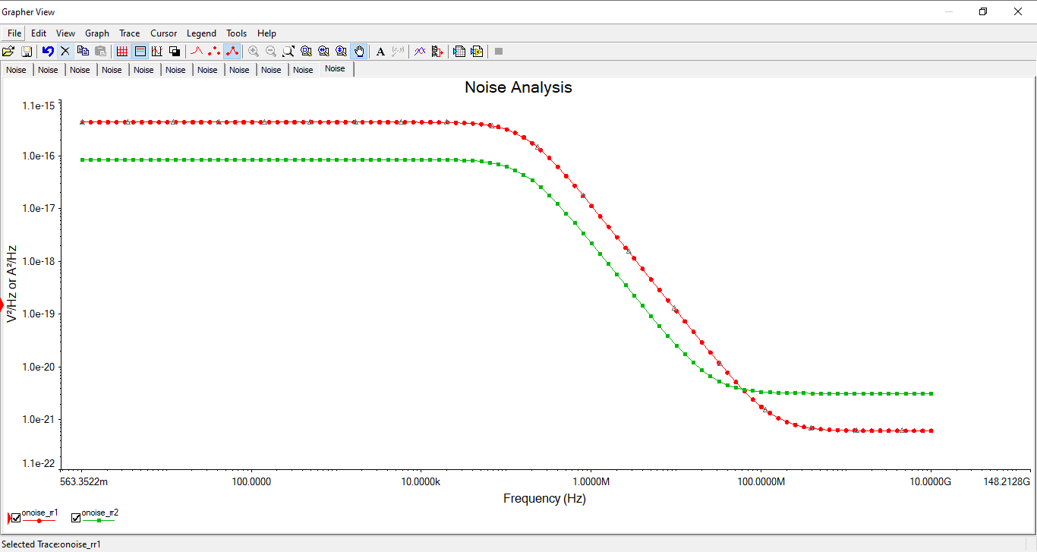

# Case C: Noise Figure analysis

Circuit Diagram:



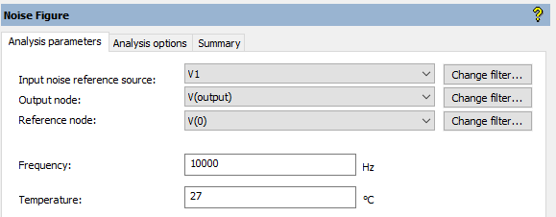Necessary Settings:

Result:

Using bode plotter, it is clear that the gain is maximum

At around 1.5MHz (1.623MHz)

